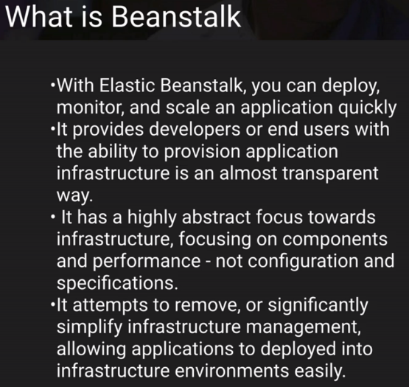This was made for Developers who are not familiar with AWS and to be able to deploy their code to the cloud quickly. They can provision environments quickly.

